Title of the Article
(12pt Times New Roman, Capitalize Each Word and Centered)

Translation of the title in second language is required
(12pt Times New Roman, Italicize, Capitalize Each Word and Centered)

First Author¹, Second Author², Third Author³
(11pt Times New Roman, Bold, Capitalize and Centered)
¹ Affiliation (School, University address, Country)
²Affiliation (School, University address, Country)
³Affiliation (School, University address ,Country)
Email: ¹abc@gmail.edu.my, ²def@gmail.edu.my^{, 2}ghi@gmail.edu.my
(10pt Times New Roman, Capitalize Each Word and Centered)

ABSTRACT
(11pt Times New Roman, Uppercase, Centered)

Write your abstract here. (11pt Times New Roman, justify, Keywords up to 5).
Abstract should be written in minimum 180 words and maximum 250 words, single spacing and should include the following: aim, method, results and conclusion. Abstract in English is required if the article is written in Malay or Arabic.

Keywords: Maximum 5 Keywords, separated with semicolon “, ”

ABSTRAK
(Abstract in English is required if the article is written in Malay or Arabic, 11pt, Italicize)

Terjemahan abstrak dalam bahasa kedua. Minimum 180 patah perkataan dan maksimum 250 patah perkataan sahaja. Ia perlu mengandungi objektif, metod kajian dan hasil/ dapatan kajian. Abstrak dalam Bahasa Inggeris diperlukan sekiranya artikel ditulis dalamBahasa Melayu atau Bahasa Arab.

Kata kunci: Maksimum 5 Kata kunci, asingkan menggunakan semicolon “ ; ”

INTRODUCTION – (11pt Times New Roman, Uppercase, Bold)
Write your content here (single spacing, 11pt Times New Roman, justify)

Subtopic Bold and Capitalize Each Word – (11pt Times New Roman, Bold)
Write your content here (single spacing, 11pt Times New Roman, justify)

Subtopic Bold and Capitalize Each Word – (11pt Times New Roman, Bold)
Write your content here (single spacing, 11pt Times New Roman, justify)

PROBLEM STATEMENT - (11pt Times New Roman, Uppercase, Bold)
Write your content here (single spacing, 11pt Times New Roman, justify)
LITERATURE REVIEW - (11pt Times New Roman, Uppercase, Bold)
Write your content here (single spacing, 11pt Times New Roman, justify)

METHODOLOGY - (11pt Times New Roman, Uppercase, Bold)
Write your content here (single spacing, 11pt Times New Roman, justify)

FINDINGS AND DISCUSSIONS - (11pt Times New Roman, Uppercase, Bold)
Write your content here (single spacing, 11pt Times New Roman, justify)
inti
Table 1: The Title of the Table Capitalize First Word
(10pt Times New Roman, Bold)
Xxxq | Xxxq | Xxxq
Xxxq | Xxxq | Xxxq
Xxxq | Xxxq | Xxxq
Note: ***, **, and * indicate ………

Figure 1: The Tittle of the Figure Capitalize First Word
(10pt Times New Roman, Bold)

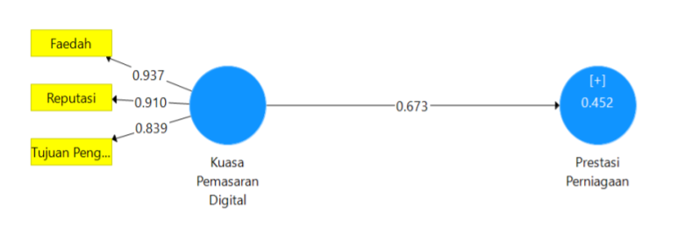

CONCLUSION – (11pt Times New Roman, Uppercase, Bold)
Write your conclusion here (single spacing, 11pt Times New Roman, justify)

ACKNOWLEDGEMENT (If Necessary) - (11pt Times New Roman, Uppercase, Bold)
Write your acknowledgement here (single spacing, 11pt Times New Roman, justify)

REFERENCES - (11pt Times New Roman, Uppercase, Bold)

- All references should be in APA 7th edition and present inside the main body of article.
- See the APA style website (https://libraryguides.vu.edu.au/apa-referencing/7FormatsAndExamples)
- Do not put extra references which are not cited.
- Reference list entries should be alphabetized (Sort A-Z Ascending).

(Single Spacing, 11pt Times New Roman, justify)
Abdul Aziz, M. (2015). Islamization of knowledge and educational development: The case of Bangladesh. International Journal of Islamic Thoughts, 4(1), 95-112.
Alavifar A, Karimimalayer M, Anuar M. K. (2012). The first and second generation of multivaritate techniques. Engineering Science and Technology: An International Journal (ESTIJ), 2(2), 326-329.
Ball, J., Armistead, L., & Austin, B. J. (2003). The relationship between religiosity and adjustment among African-American, female, urban adolescents. Journal of Adolescence, 26(4), 431-446.

